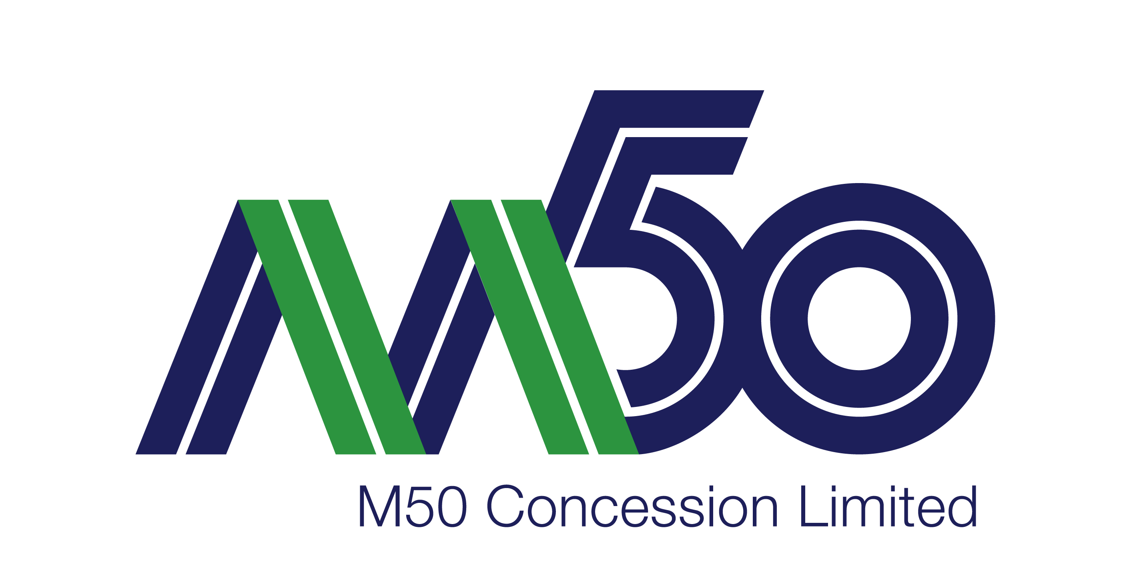 | CLAIM/COMPLAINT FORM | M50OP 316 F.09 | Issue No.: 01
 | CLAIM/COMPLAINT FORM | Issue Date: 07/04/2014 | Page 1 of 2

Please Complete Sections 1 & 2 and return within 2 days to M50 Concession Limited by email, fax or post.

CONTACT DETAILS |  |  |  |  |  |  | Complaint Ref No:
Name |  |  |  |  |  |  | Home Telephone No:
 |  |  |  |  |  |  | Mobile No:
Address: |  |  |  |  |  |  | Email Address:
County/Town:
COMPLAINT/CLAIM DETAILS
Date: | Time: |  |  |  |  | Location:
Nearest Junction: |  |  |  |  |  | Direction: Northbound Southbound
Detailed Description:
M50 CONCESSION LIMITED OFFICIAL USE ONLY
Health & Safety |  |  |  | Date Received: |  |  |  | Date Letter Sent:
Construction |  |  |  | Notes:
Operation & Maintenance
Finance & Administration
Actions:
Details of how complaint closed:
Office Manager: |  |  | Date: |  | Closed By: |  |  |  | Date:

- YOU MUST COMPLETE THE ENTIRE FORM.
- MAKE SURE TO ENCLOSE COPIES OF IMPORTANT DOCUMENTS RELATED TO COMPLAINT I.E. STATMENTS, PHOTOGRAPHS, ETC.
- YOUR COMPLAINT WILL BE TREATED AS CONFIDENTIAL AND HANDLED IN ACCORDANCE WITH THE DATA PROTECTION ACT 1988, 2003 AND THE EUROPEAN UNION GGPR 2018.

How would you like to be contacted? Email Phone Post I do not want to be contacted

